Charles Henderson

Reuel Maddela

Harpreet Sidhu

Bass

Milestone 2

Here are screenshots of login and registration code working in MySQL Workbench.

User Model (First version):

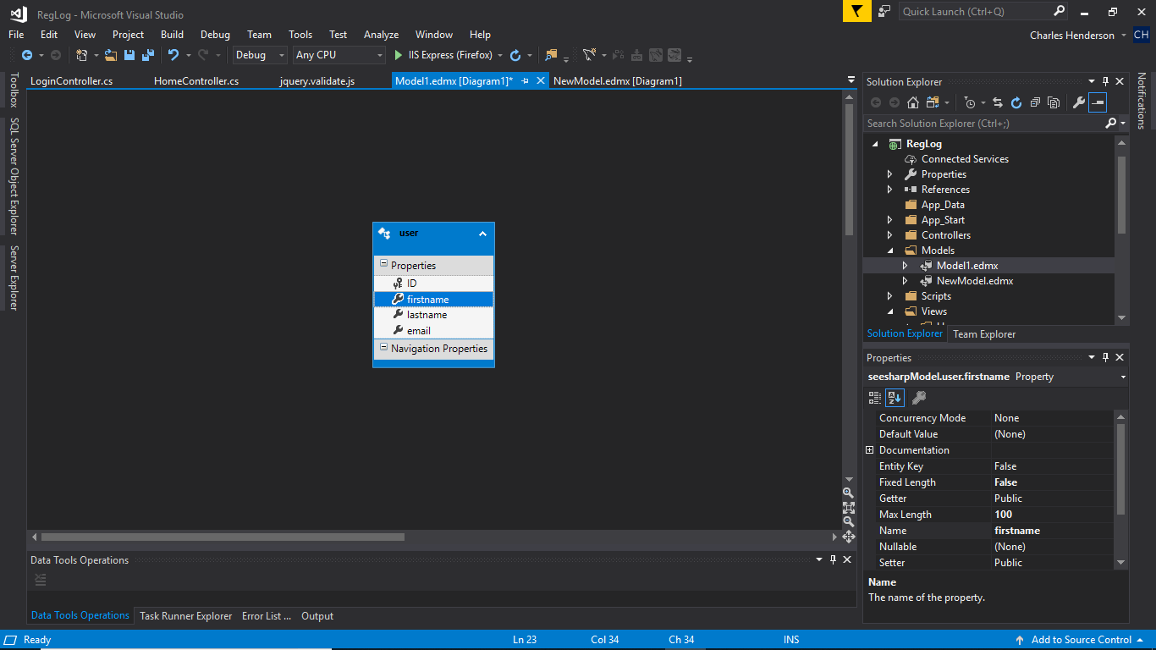

MySQL model code in Visual Studio

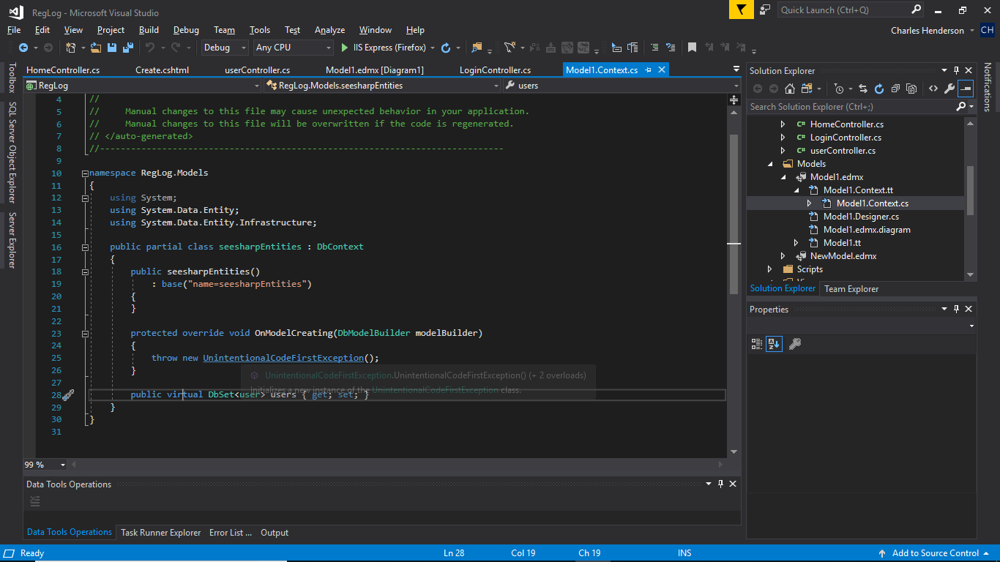

User Controller(Registration Page and User Editing):

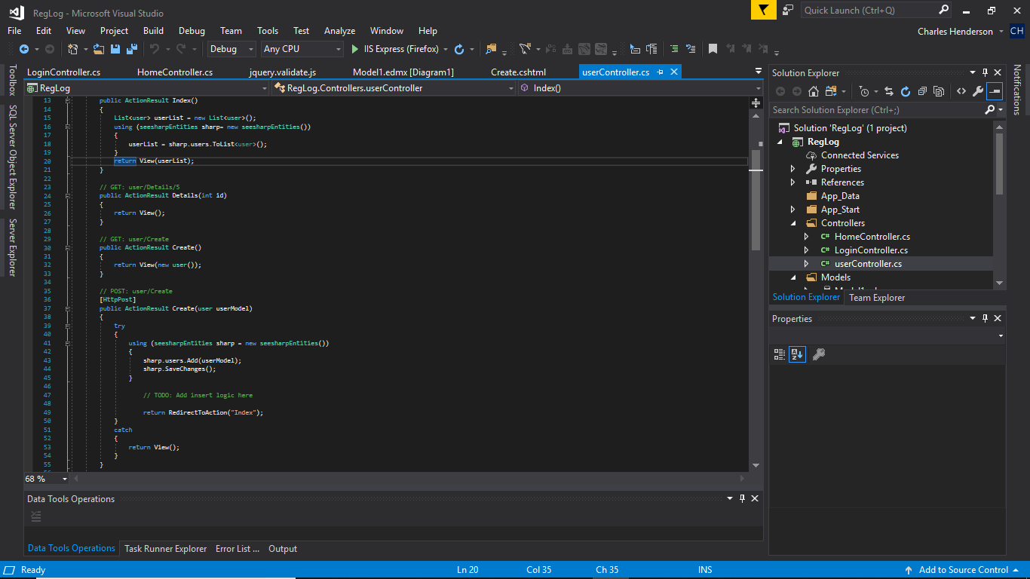

What this looks like when going to the url:

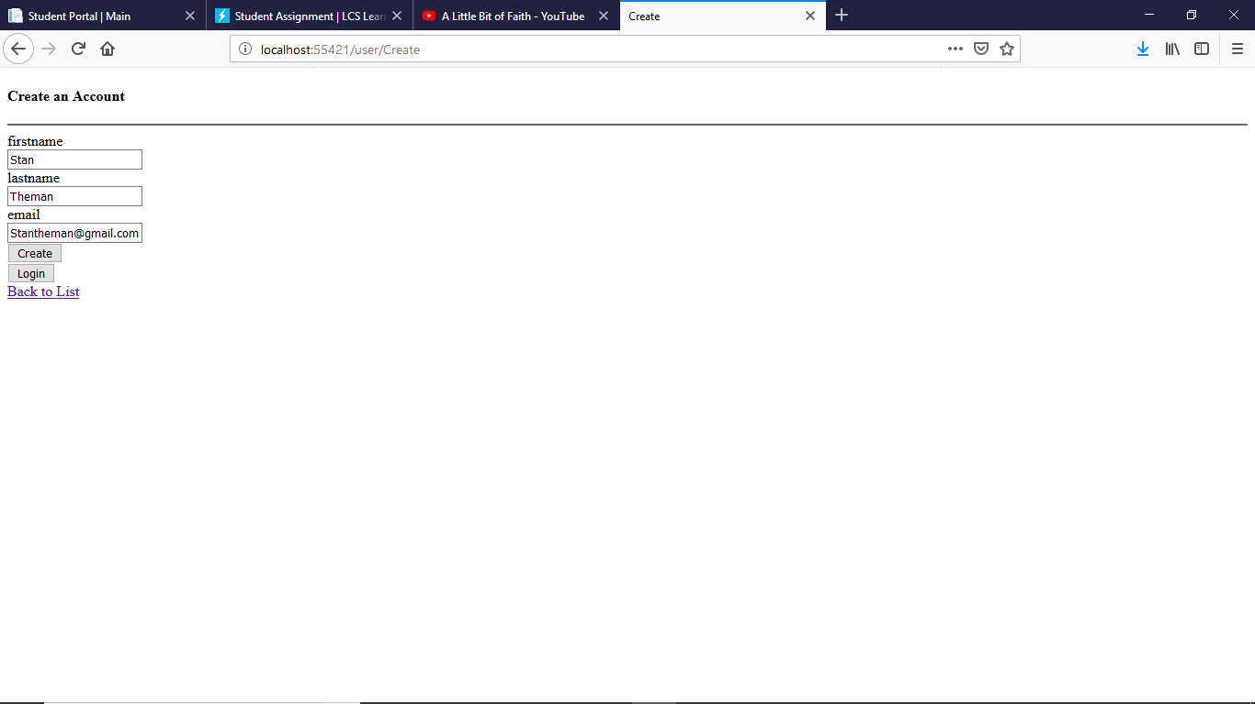

The results page of all the registered users after hitting create:

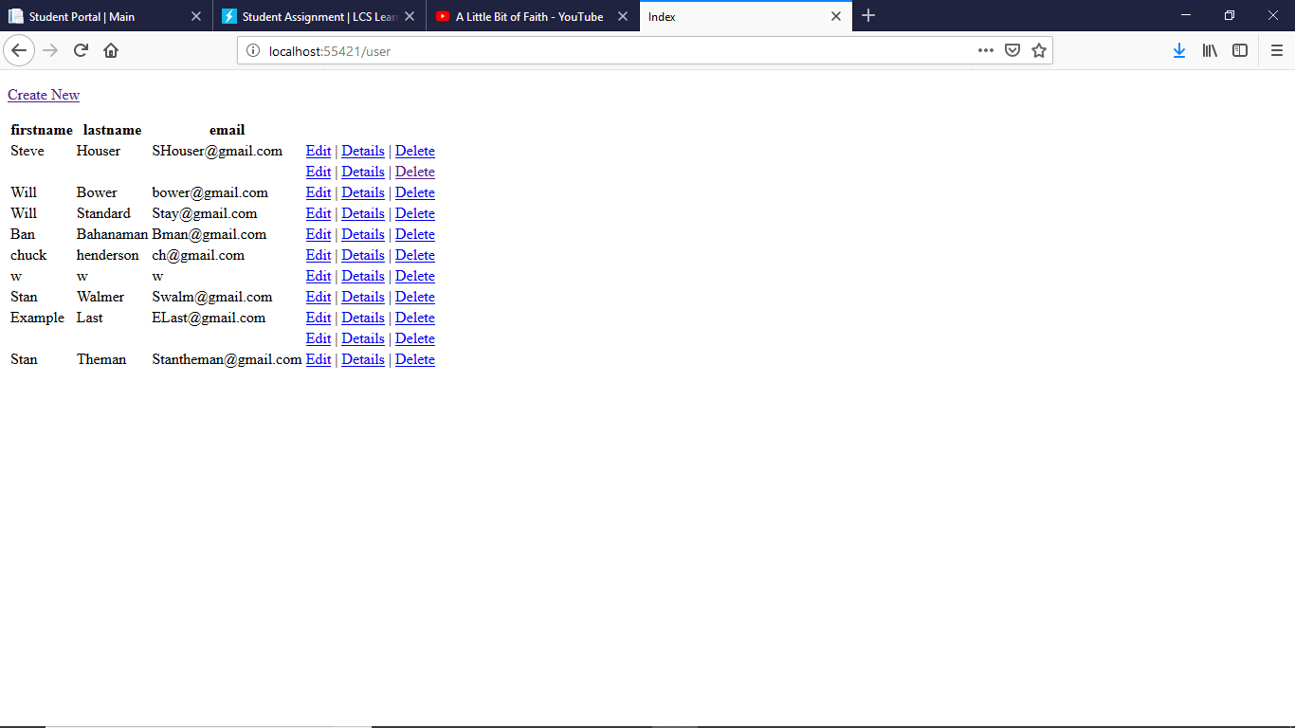

The resulting data in the MySQL Database:

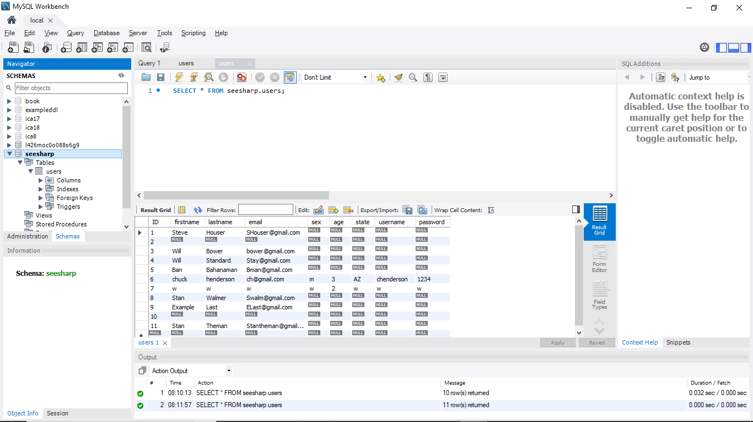

Login Controller:

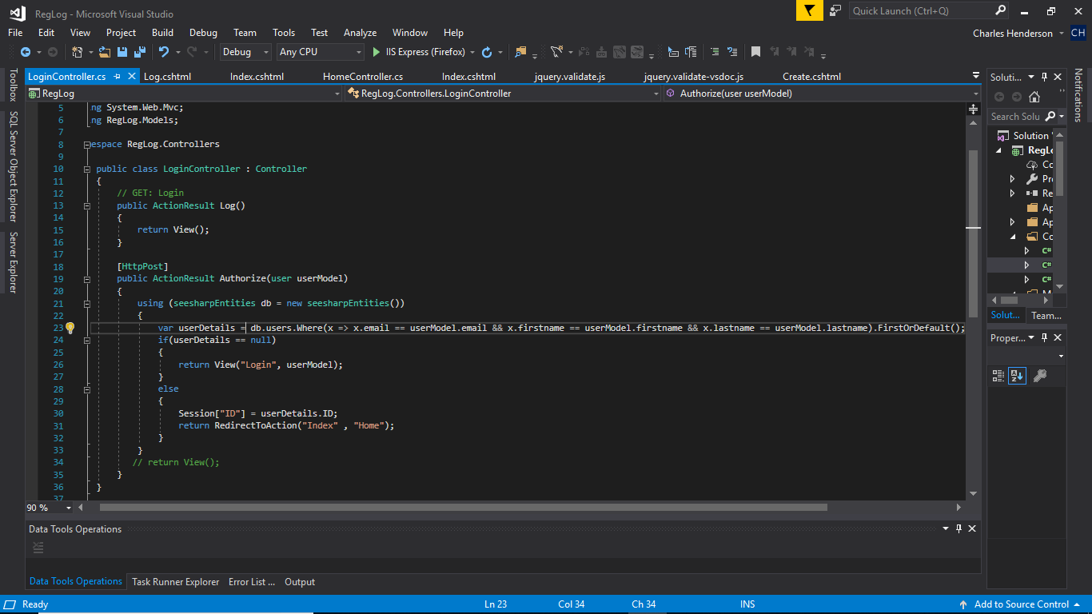

Login Page:

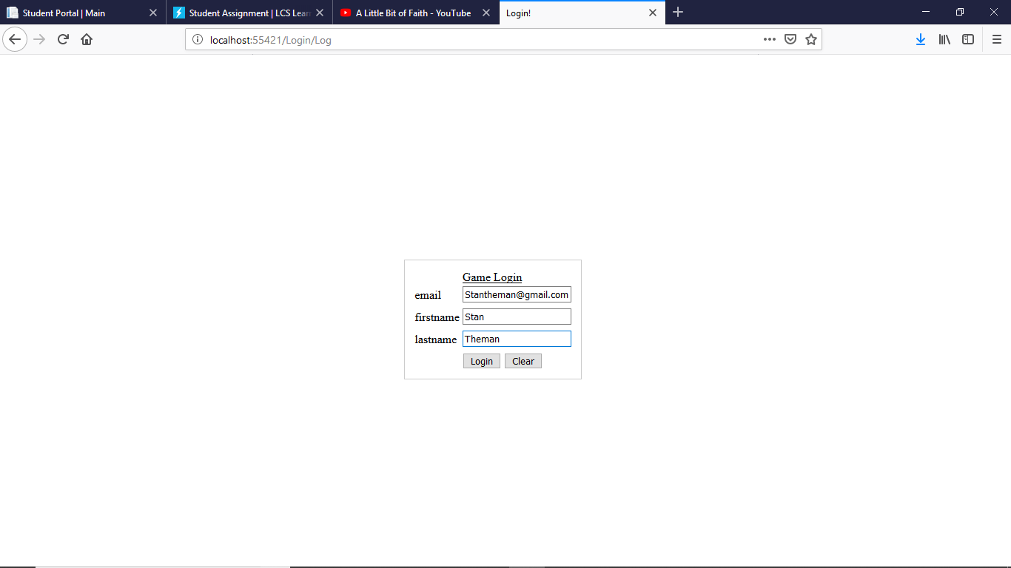

After inputting correct information:

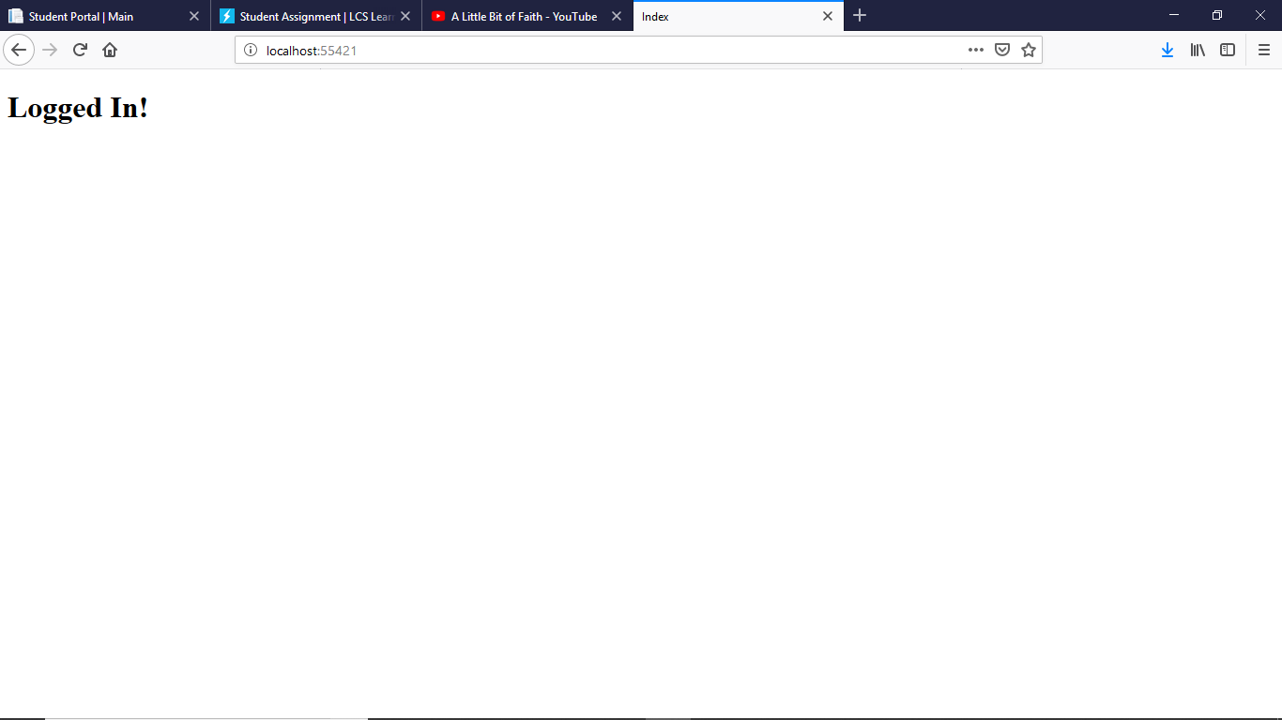

Else you get: 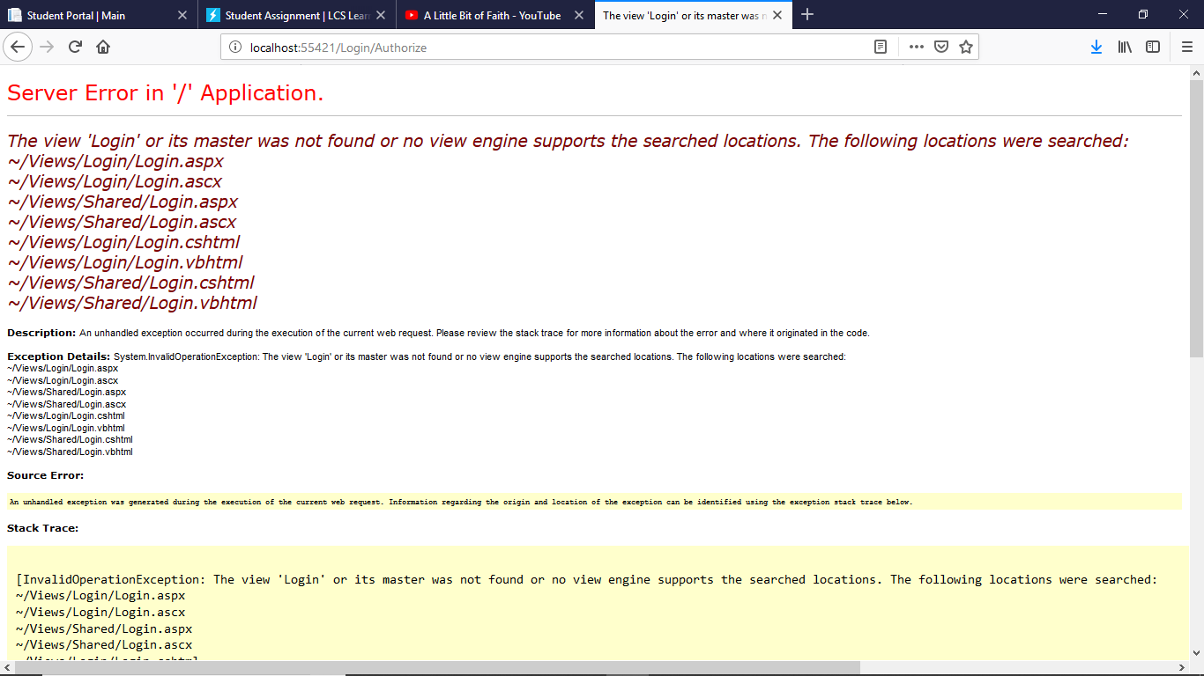

Here are some of the views html pages (All this code is included in submission): 